**Code and Output for Apex Class Assignment**

**Code:**

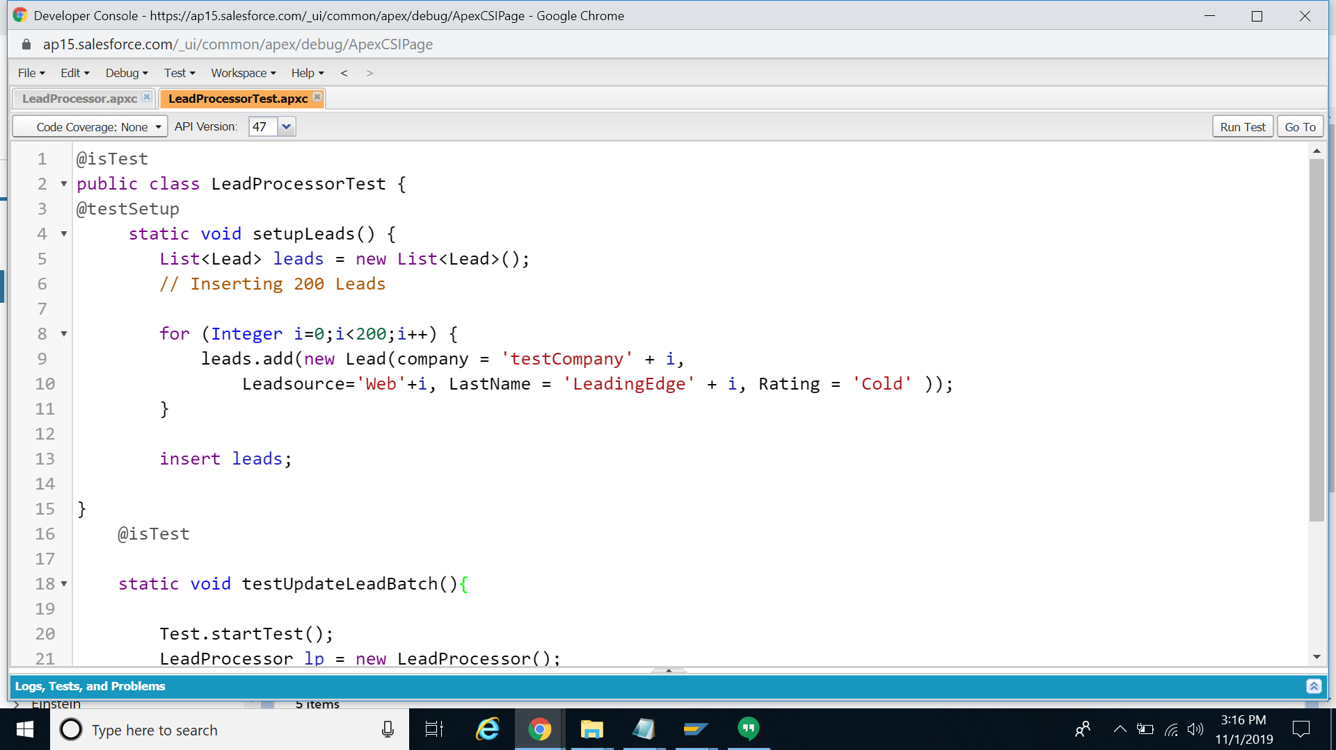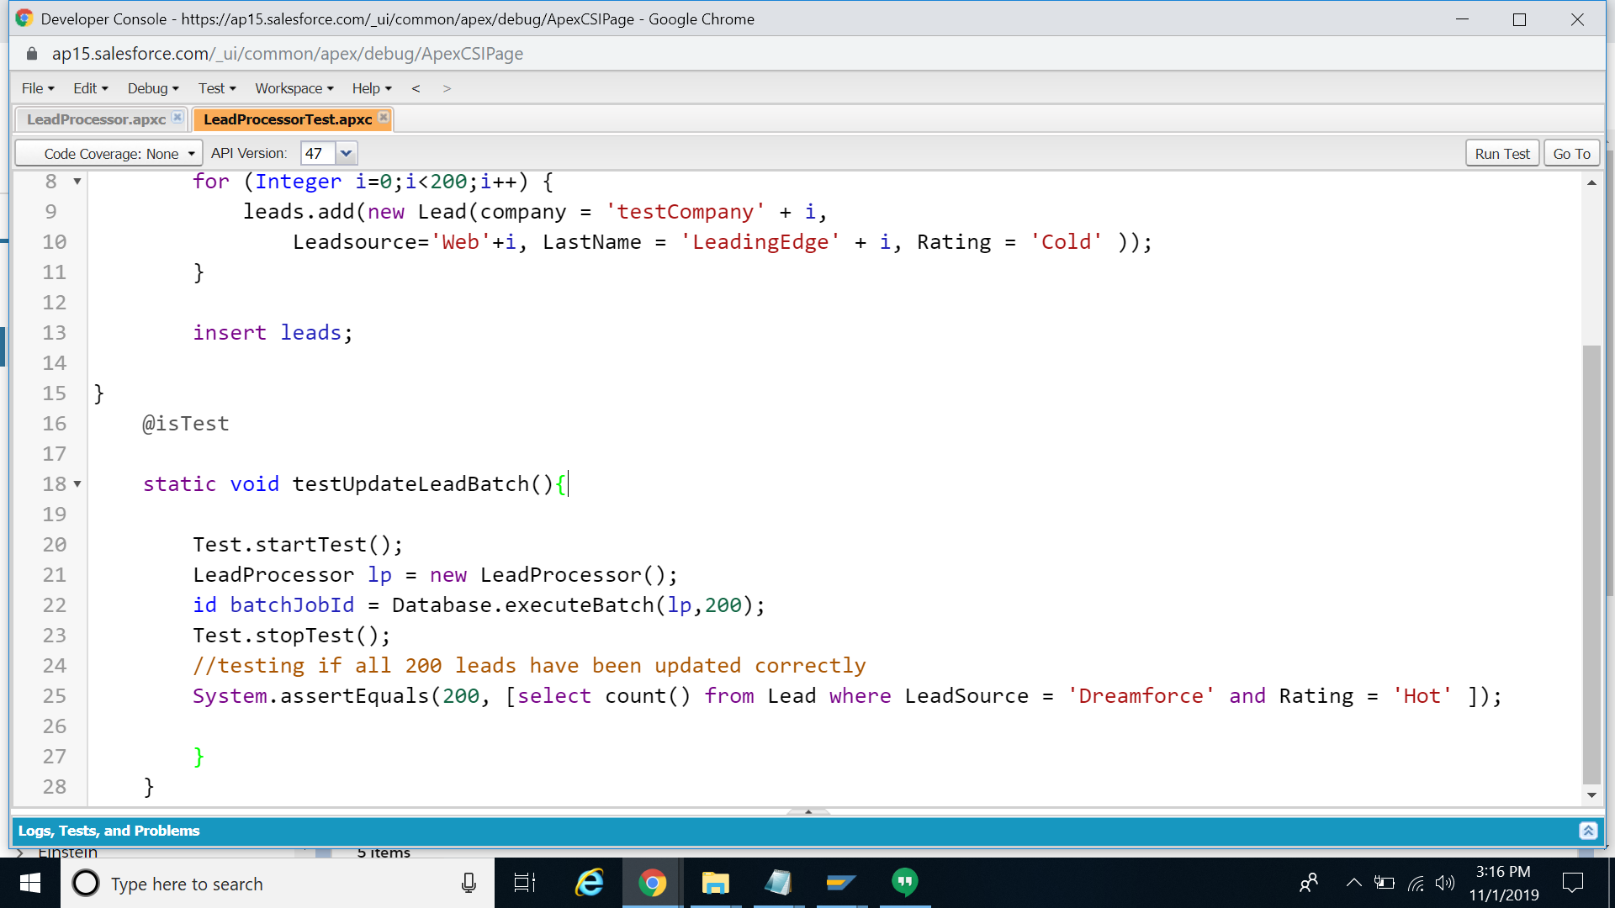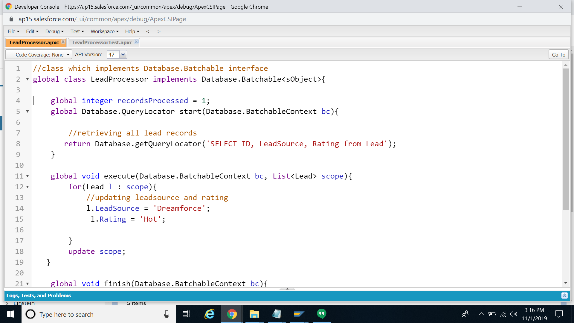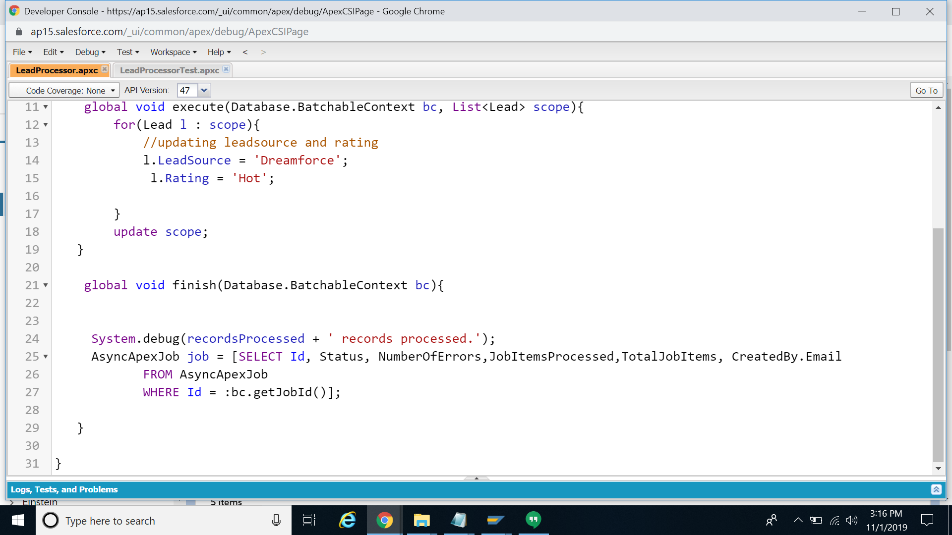

The LeadProcessor class implements the Database.batchable interface and updates the Lead records with LeadSource as dreamforce and rating as Hot. A test class LeadProcessorTest is used to test the same by generating 200 leads with dummy lead source and rating values.

**Output**

100% Code Coverage.

